Accepted in 4th International Conference on Hybrid and Organic Photovoltaics to be celebrated in Uppsala, Sweden, 6 - 9 May 2012

Flavylium salts as novel photosensitizers for dye-sensitized solar cells.

Giuseppe Calogero¹, Alessandro Sinopoli¹, Ilaria Citro¹, Gaetano Di Marco¹ Vesselin Petrov², Ana M. Diniz², A. Jorge Parola², Fernando Pina².

1) CNR, Istituto per i Processi Chimico-Fisici, via F.Stagno D’Alcontres 37, I-98158 Messina, Italy
2) REQUIMTE, Departamento de Química, Faculdade de Ciências e Tecnologia, Universidade Nova de Lisboa, 2829-516 Caparica, Portugal

Abstract
Seven flavylium salt dyes were employed for the first time as novel sensitizers for dye-sensitized solar cells (DSSCs). Photophysical and photoelectrochemical measurements showed that these flavylium dyes are very promising for DSSC applications [1]. Among the investigated compounds, the best performance has been obtained by a DSSC based on the novel 7-(N,N-Diethylamino) - 3’,4’-dihydroxyflavylium salt. Our results suggests that the substitution of a hydroxylic group with an diethylamine unit (NC₂H₅) into the position 7 of ring A of flavylium framework expanded the p-conjugation in the dye and thus resulted in a high absorption in the visible region and is advantageous for effective electron injection from the dye into the conduction band of TiO₂. In addition, the amine group, owing to its strong electron-donor ability, might play an important role in electron injection in addition to a red shift in the absorption region. This work open new possibility to develop new class of sensitizers synthetic analogues of natural anthocyanidins.

- F. Pina, M. J. Melo, C. A.T. Laia, A. Jorge Parola, J. C. Lima Chem. Soc. Rev. 2011, 41, 869.

Dye sensitized solar cell based on flavylium compound

Figura 1 (7-diethylamino-3’,4’-dihydroxyflavylium)

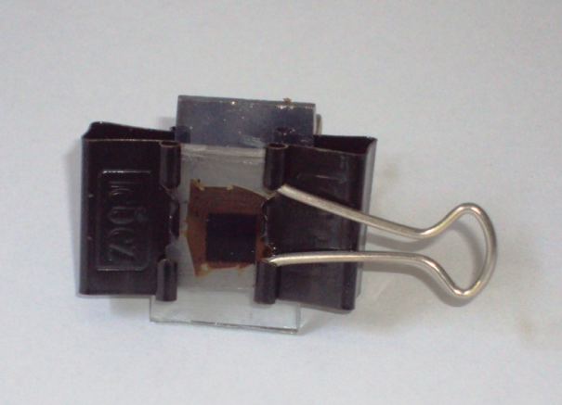

Figura 2 Parafilm sealed DSSC based on flayilium

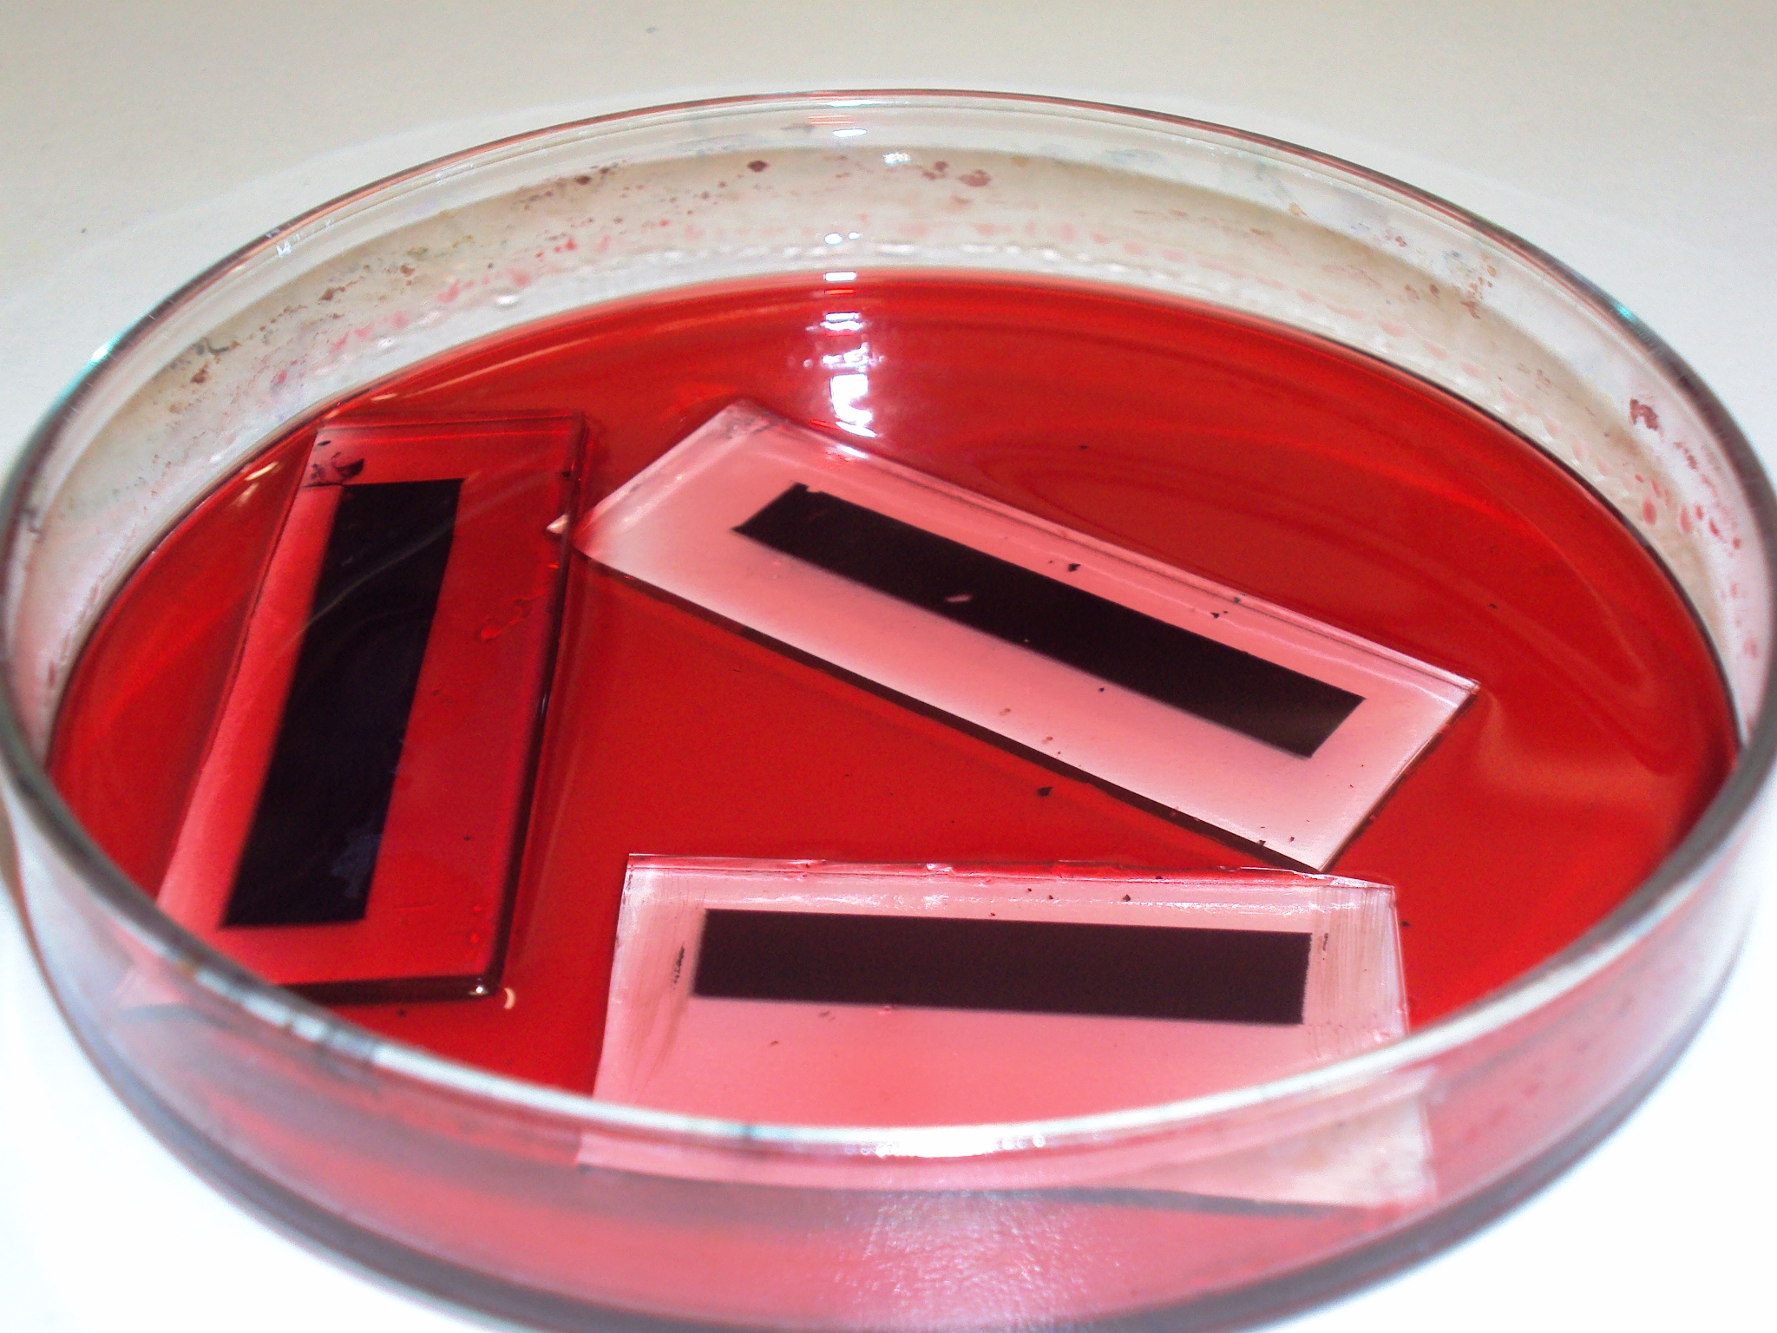

Figura 3 Flavylium based photoanodes

